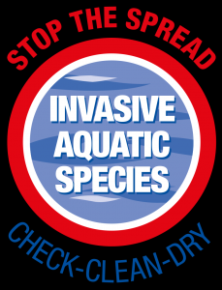

Ditch the Hitchers: Go Swim Loch Lomond Athlete Guide to Bio Security

What is Bio Security? - “Biosecurity means taking action in order to minimise the risk of the introduction or spread of invasive non-native species and diseases”

Why should we worry? -The freshwater resources of Loch Lomond and Trossachs National park – its many Lochs, Rivers and Straths – are of great ecological and economic significance. We love spending time in and on them so protecting them is something we all need to take responsibility for. Freshwater INNS are able to ‘hitchhike’ on our equipment, footwear, clothing and boats. When we move to a new river, tarn or lake, a species may be transferred and may become established, often having devastating effects.

What can we do to help? - as keen outdoor and sports enthusiasts - we all need to help protect the landscapes that we love. The bio security at the festival will involve just a little extra cooperation and organisation by you. You will be required to ensure that your wetsuit is clean and dry before you arrive and that it is cleaned before you leave. The purpose of this is to do our bit to try and stop the spread of invasive aquatic species.

The process at the race will be:

- You will ensure that all equipment to be taken into the water is clean and dry before you arrive on the race morning.
- If you are taking part in the Aquathlons, after the race and before removing anything else from the transition area, go to the washing point with your wetsuit, goggles, swim cap etcetera and your race number.
- Check your equipment for obvious vegetation or other aquatic life and remove anything found.
- Wash all above mentioned equipment in the fresh water and tubs provided.
- Once done to their satisfaction, a steward will mark your race number to indicate that your equipment has been cleaned.
- When you later leave the transition area with all of your other equipment show your appropriately marked race number to the transition exit steward who will check it
- Compliance with this process is essential to ensure that we are able to pursue our sport in such beautiful surrounding
For more Information on:
- Clean
- Check
- Dry
Please visit: https://www.lochlomond-trossachs.org/things-to-do/water-activities/swimming/
and
https://www.lakedistrict.gov.uk/visiting/things-to-do/water/swimming

